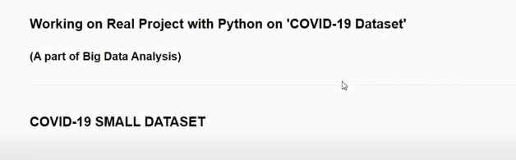

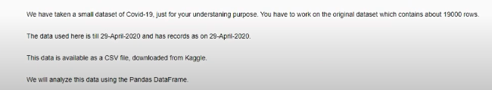



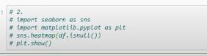

Q. 1) Show the number of Confirmed, Deaths and Recovered cases in each Region.

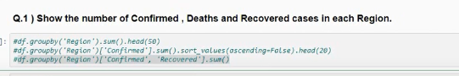

Q. 2) Remove all the records where Confirmed Cases is Less Than 10.

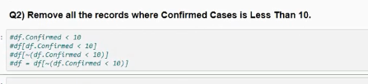

Q. 3) In which Region, maximum number of Confirmed cases were recorded ?

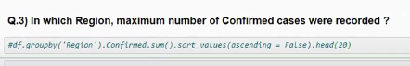

Q. 4) In which Region, minimum number of Deaths cases were recorded ?

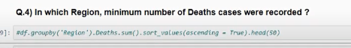

Q. 5) How many Confirmed, Deaths & Recovered cases were reported from Bangladesh till 29 April 2020 ?

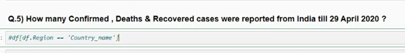

Q.6-A) Sort the entire data wrt No. of Confirmed cases in ascending order.

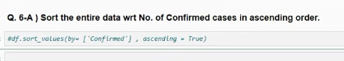

Q.6-A) Sort the entire data wrt No. of Recovered cases in descending order.

